SET – 2
Git:
Step 1: Create HTML code for the given scenario
Step 2: git init
Step 3: git add .
Step 4: git commit -m "Initial commit"
Step 5: git branch -M main
Step 6: git remote add origin https://github.com/HarithaNivrithi/Agile-Set-B.git
Step 7: git push -u origin main
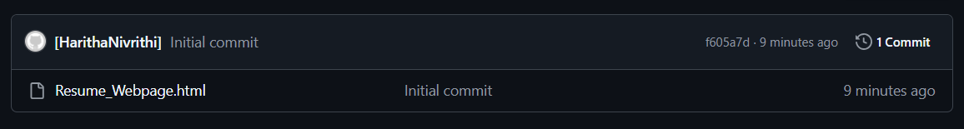
Step 8: git clone https://github.com/HarithaNivrithi/Agile-Set-B.git
Step 9: cd Agile-Set-B (Use the name of your git repository)
Step 10: code . (It’ll open your folder and code in a new window in VS, Continue to work in the new window’s terminal in VS)
Step 11: Make the changes asked according to the question
Step 12: git add .
Step 13: git commit -m "Updated Resume Webpage”
Step 14: git push
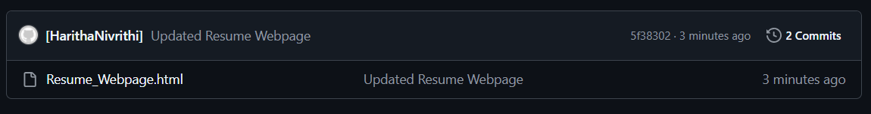
Docker:
Step 15: type null > Dockerfile
Step 16: Paste the code given for Dockerfile (From any AI)
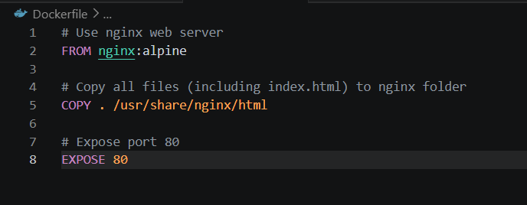
Step 17: docker build -t harithanivrithi/resume-app . (Must include your docker hub username. Example: harithanivrithi/example)
Step 18: Check Docker Hub -> Images and Builds for the output. Also run (docker images) command in the vs terminal for terminal confirmation.
Step 19: docker push harithanivrithi/resume-app (Pushes image into Docker Hub Cloud)
Step 20: docker run -d -p 8081:8080 harithanivrithi/resume-app
Step 21: https://localhost:8081 (To open HTML webpage)
Jenkins:
Step 22: Download all necessary plugins – docker, Kubernetes.
Pipeline Script:
pipeline {
agent any

stages {

stage('Clone') {
steps {
git branch: 'main', url: 'https://github.com/HarithaNivrithi/Agile-Set-B.git'
}
}

stage('Build Docker Image') {
steps {
bat 'docker build -t resume-app .'
}
}

stage('Run Container') {
steps {
bat 'docker run -d -p 8082:80 resume-app'
}
}
}
}

Step 23: Build and ss output
Kubernetes:
Step 24: type null > deployment.yaml
Step 25: Paste the code given for Deployment.yaml (From any AI)
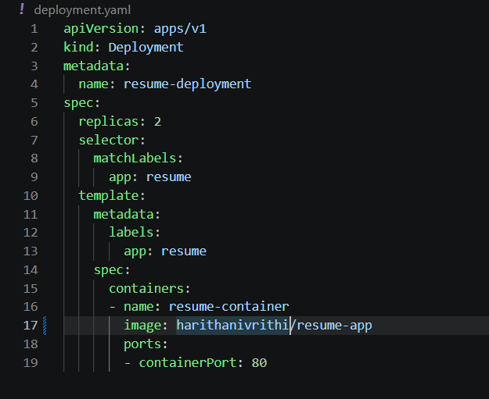
Step 26: type null > service.yaml
Step 27: Paste the code given for service.yaml (From any AI)
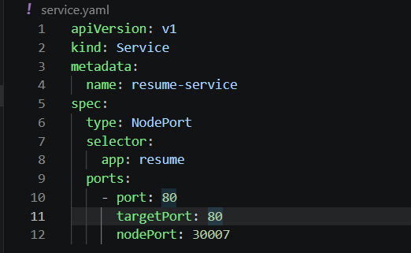
Step 28: kubectl apply -f deployment.yaml
Step 29: kubectl apply -f service.yaml
Step 30: kubectl get pods (To get Kubernetes output)
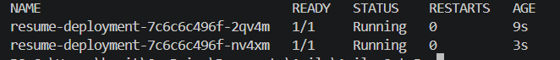
Step 31: Kubernetes output from Docker Hub:
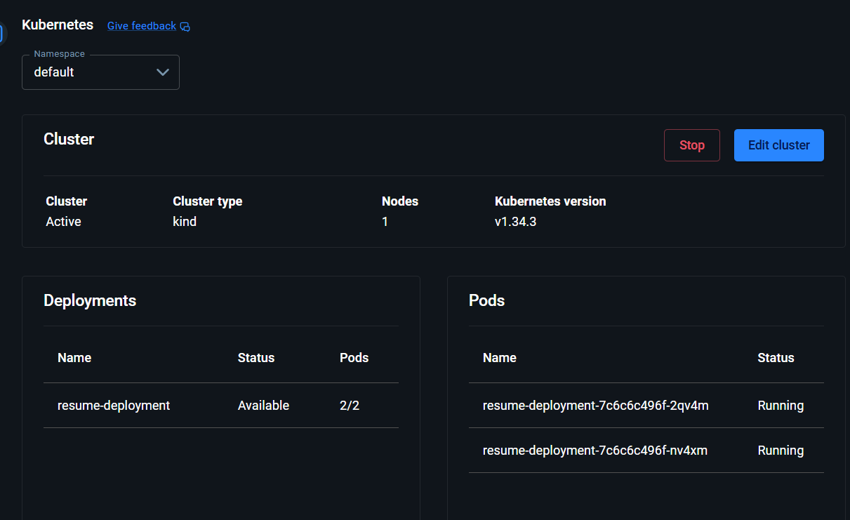

If ErrImage or status 0/1 occurs:
